**NAME: OMKAR GHARAT**

**ENROLLMENT NO.:2101950**

**CLASS: M. SC. (COMPUTER SCIENCE)**

**Assignment No: 7**

**Write a program for web feed**

Start the lab

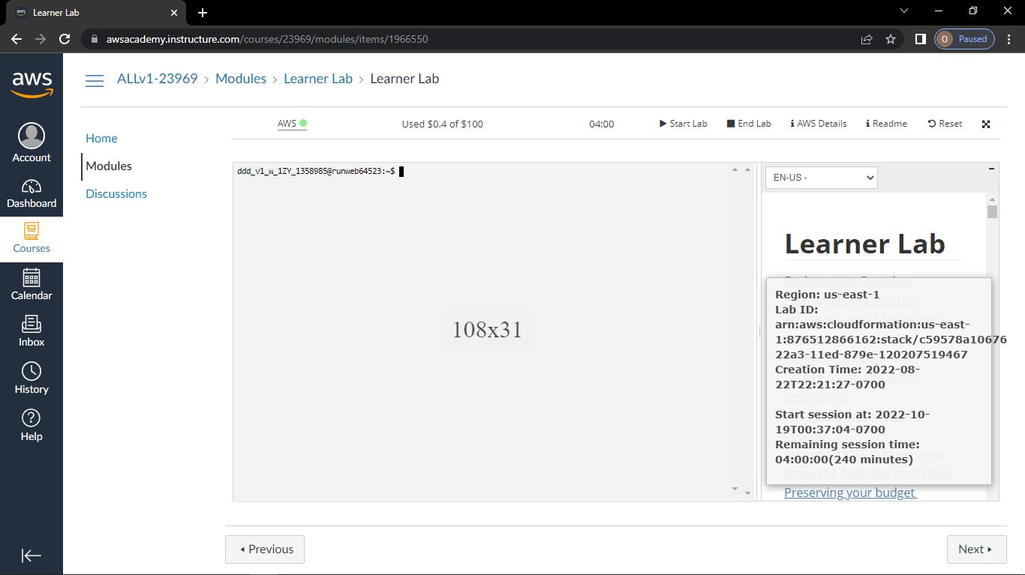

Click on EC2 Service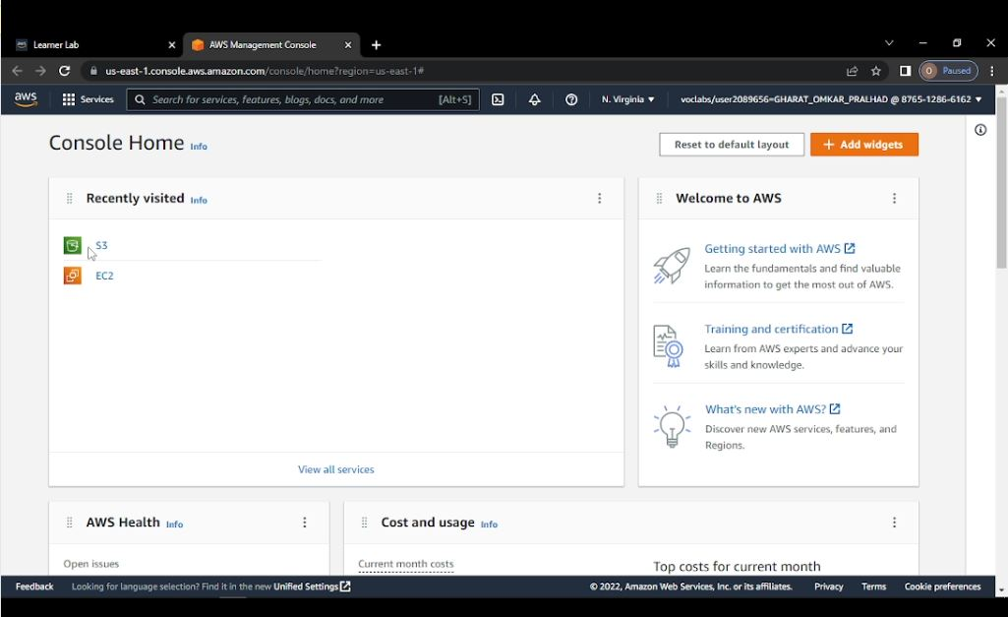

Launch instance

Click on launch instance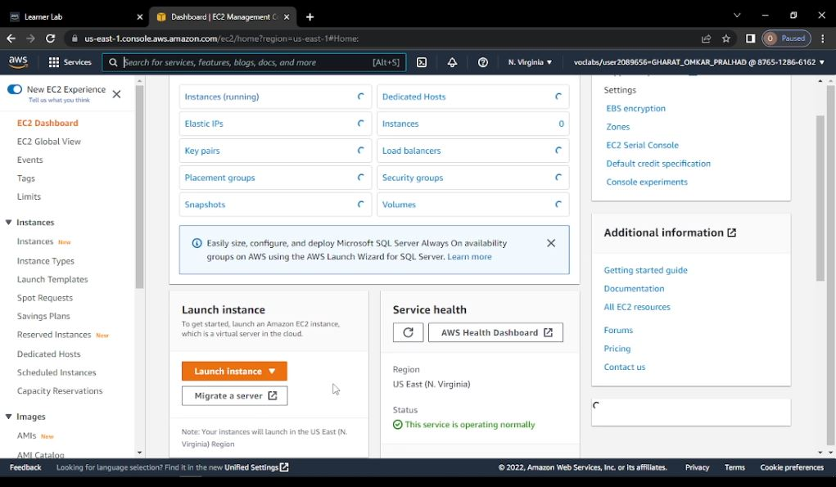

Give name to the instance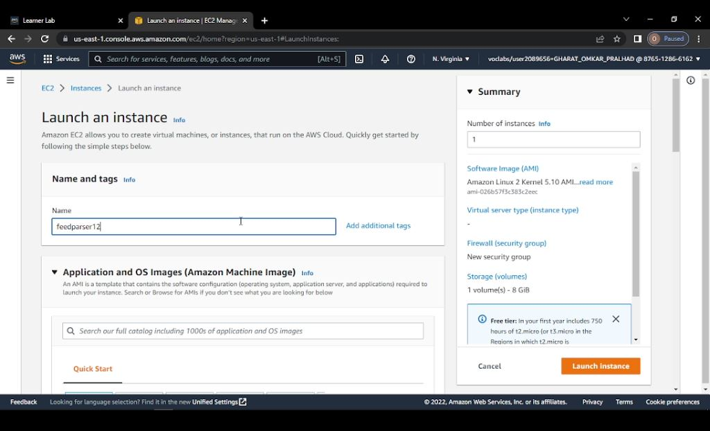

Create key-pair and give the name to the key pair->click on create key pair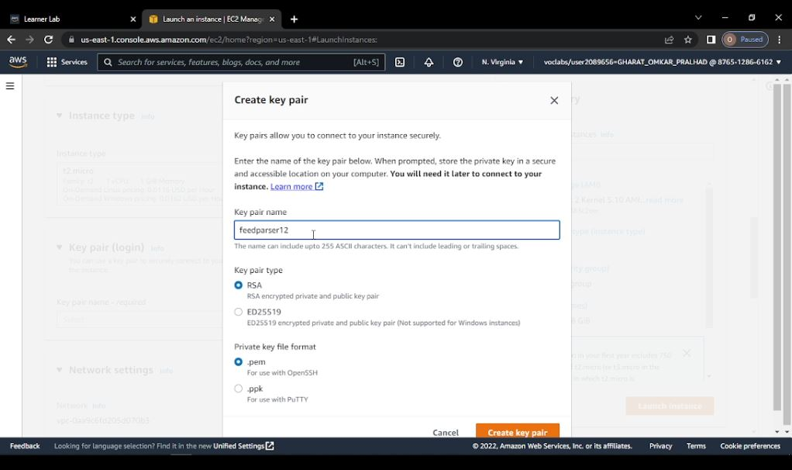

Key-pair name .pem file gets downloaded i.e. feedparser12.pem

In network setting check on allow HTTPS traffic from the internet and click on Launch instance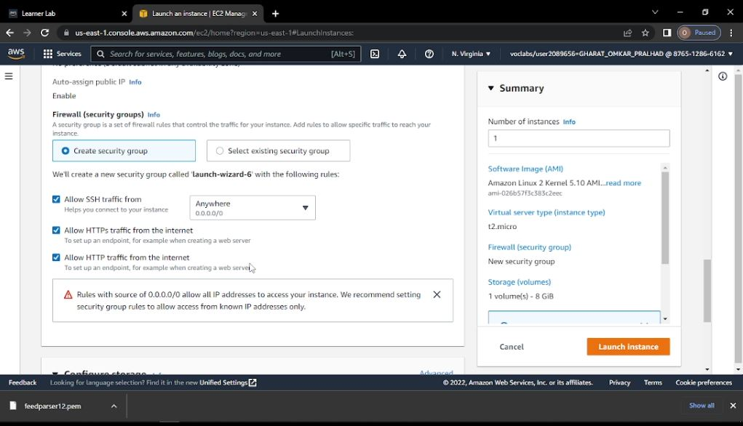

Now click on view all instances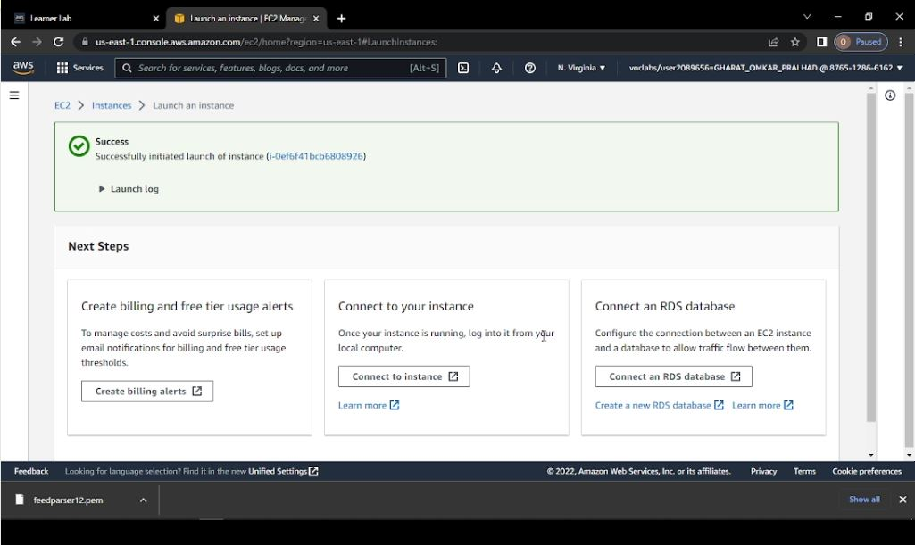

Open Putty Gen=>Load=>open key-pair .pem file which was downloaded i.e. feedparser12.pem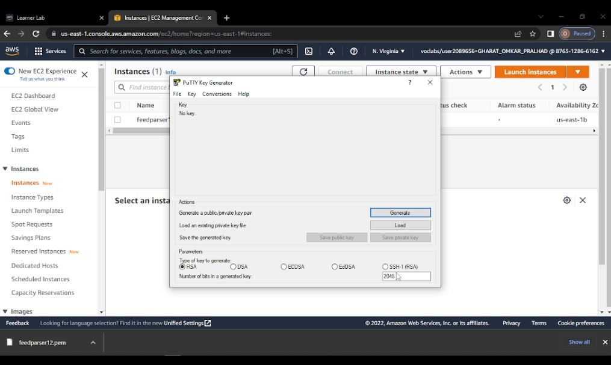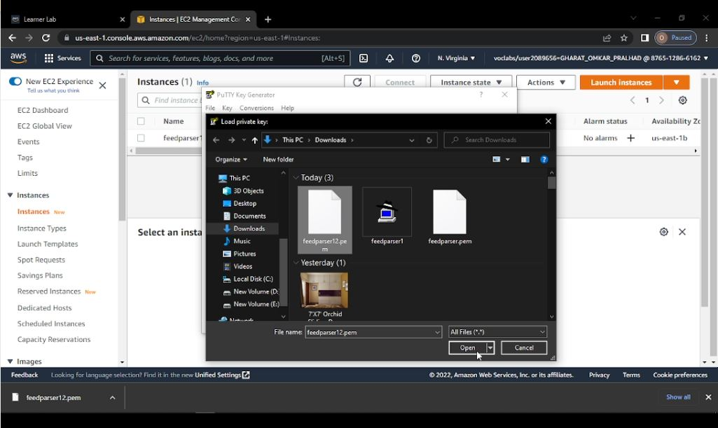

Click on OK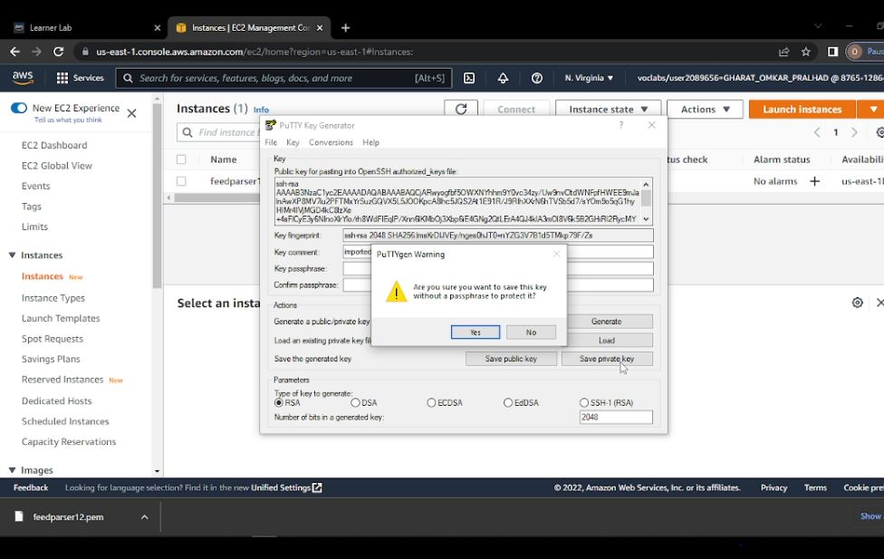

Give the name to priavte key i.e. feedparser.ppkand save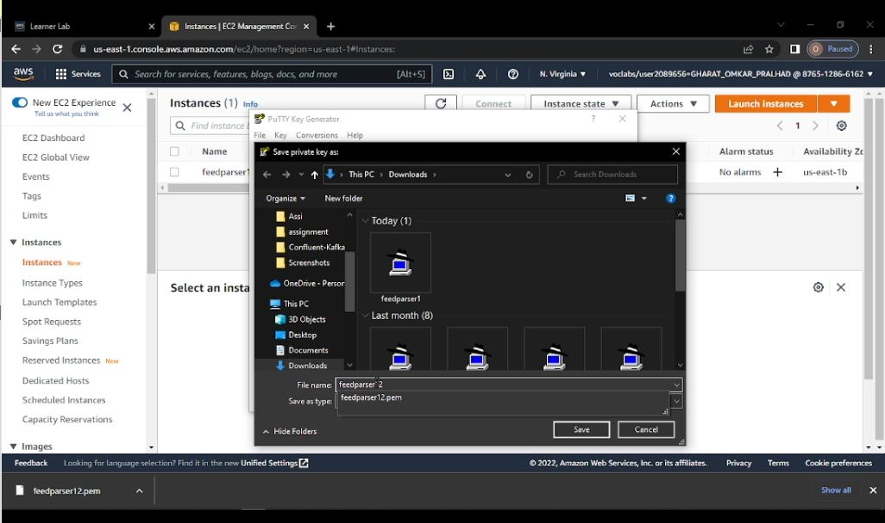

Check on instance and copy the public IPv4 address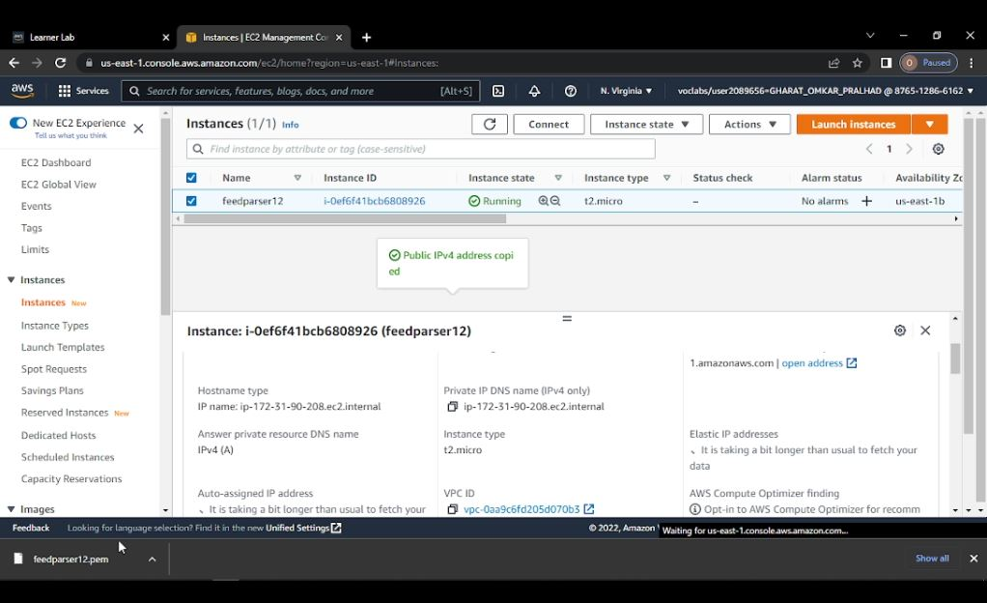

Now Open Putty and paste the copied IPv4 address under HostName

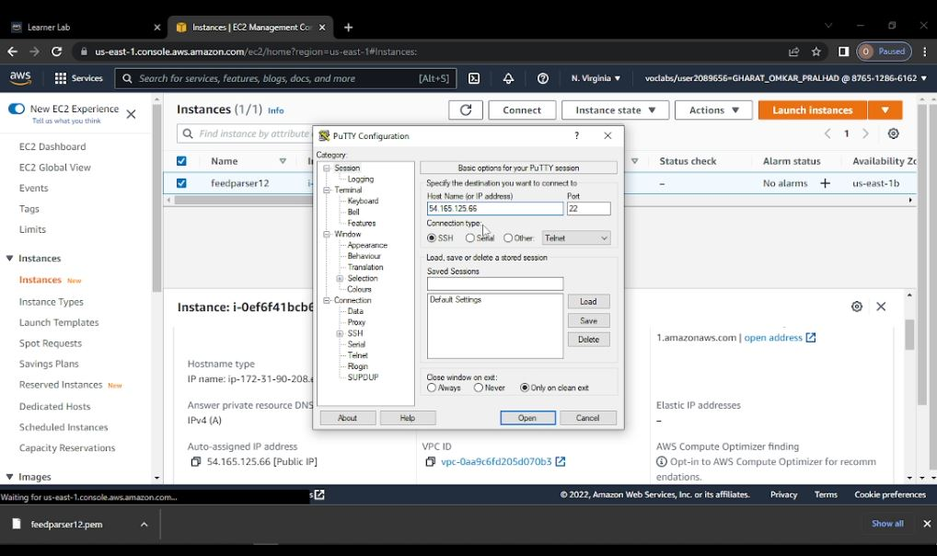

Click on SSH=>Auth=>Browse=>private key which we have created i.e. feedparser.ppk=>Open

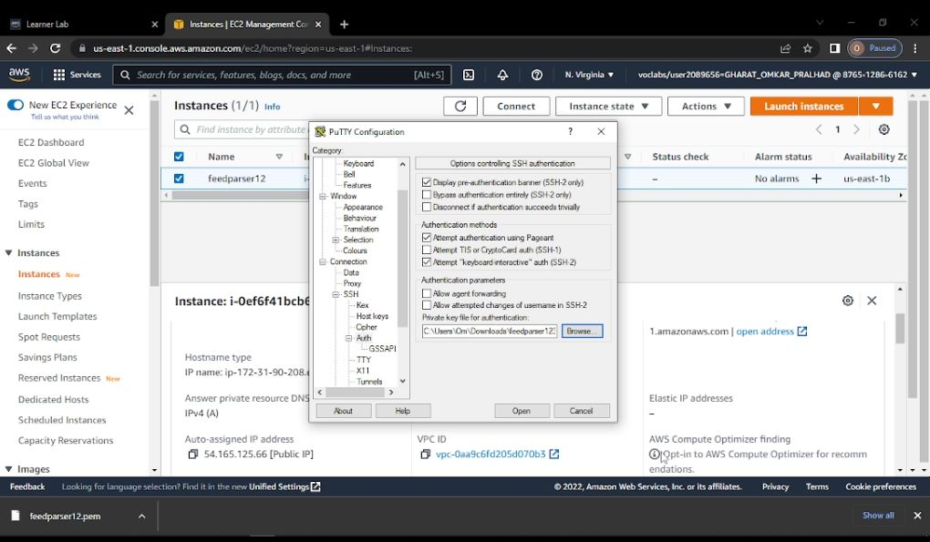

Click on accept =>Yes

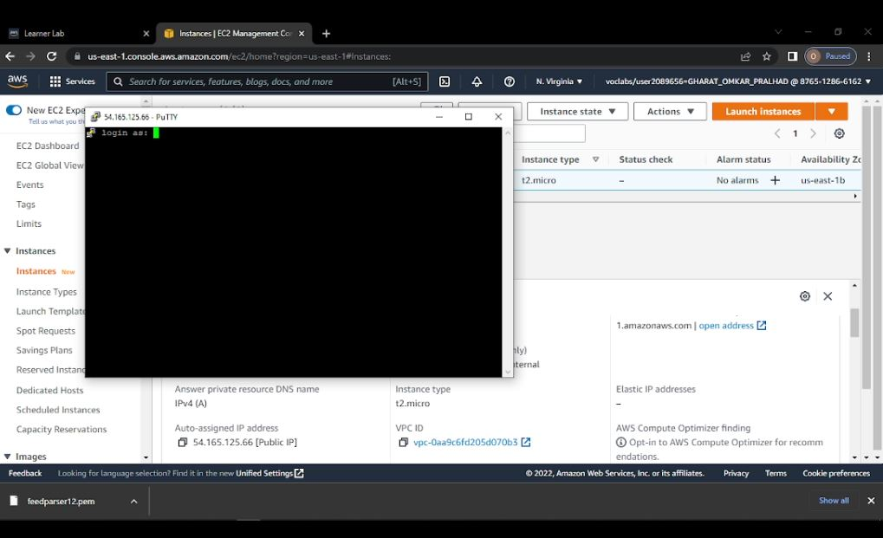

Type following commands

login as: ec2-user

[ec2-user@ip-172-31-90-208 ~]$ sudo su

[root@ip-172-31-90-208 ec2-user]# yum install python

[root@ip-172-31-90-208 ec2-user]# yum install pip

[root@ip-172-31-90-208 ec2-user]# pip install feedparser

[root@ip-172-31-90-208 ec2-user]# vi om.py

In om.py type

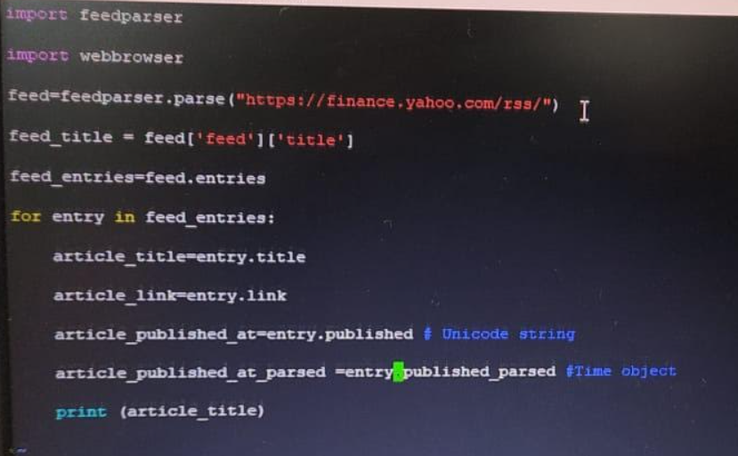

[root@ip-172-31-90-208 ec2-user]# python om.py

OUTPUT

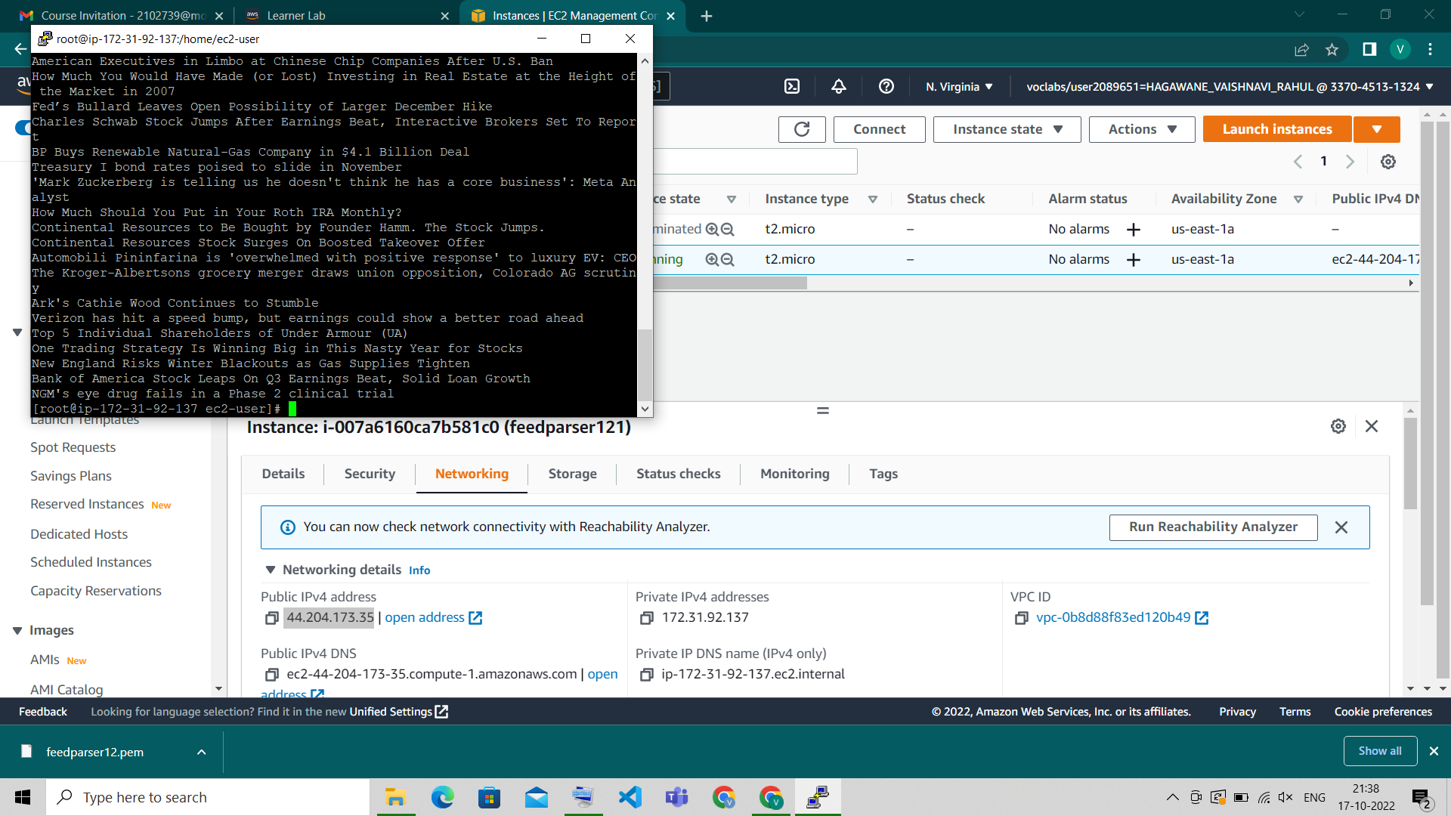

Terminate the instance and end the Lab